
Atomic Structure Assignment – Validation Test
Name:
/50

Part A: Multiple Choice [10 marks]
Choose the best answer and write ALL your answers in the appropriate box below:

1 | 2 | 3 | 4 | 5 | 6 | 7 | 8 | 9 | 10

- Which of the following represents a chromium (III) ion with 28 neutrons?
  - 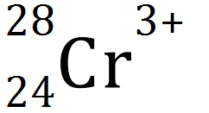
  - 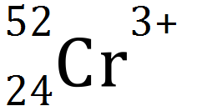
  - 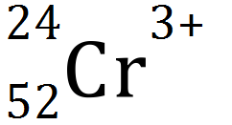
  - 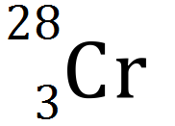

- Which one of the following species does not have an electron configuration of 2,8?
  - Ne
  - F⁻
  - Na
  - O²⁻

- The successive ionisation energies for an element, Y, are shown below.

Equation for process | Ionisation Energy  (kJ mol⁻¹)
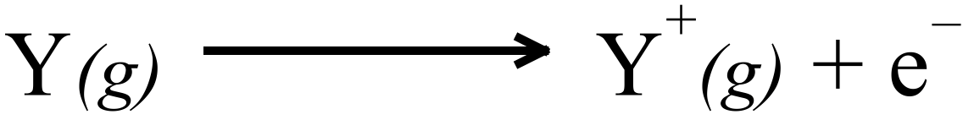 | 1000
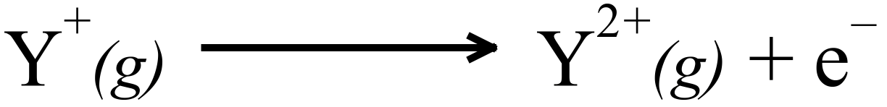 | 2252
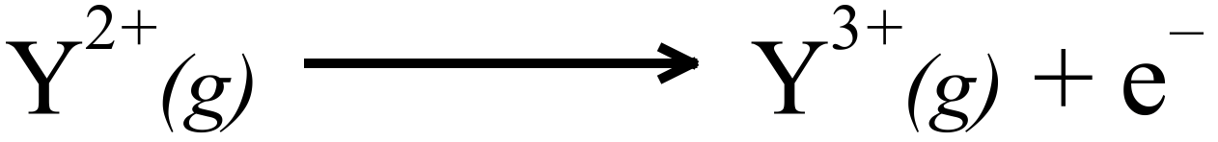 | 3357
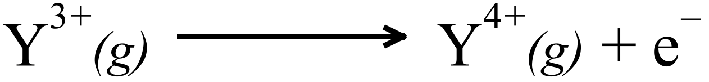 | 4556
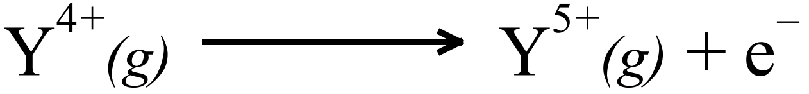 | 7004
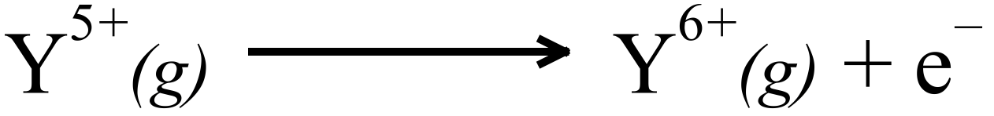 | 8496
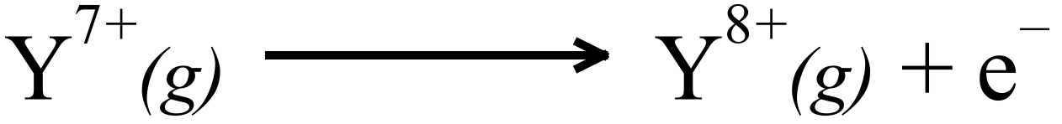 | 27107
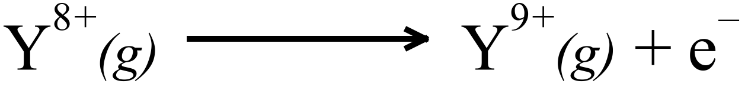 | 31719
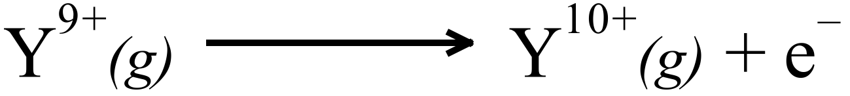 | 36621
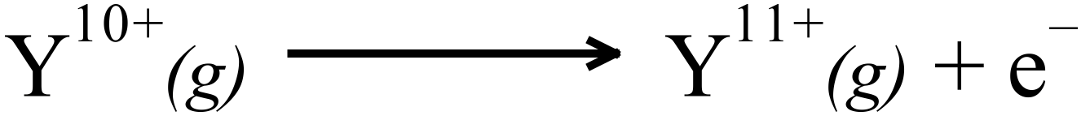 | 43177
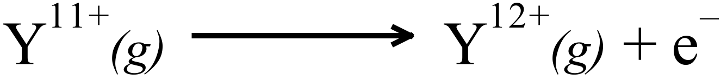 | 48710
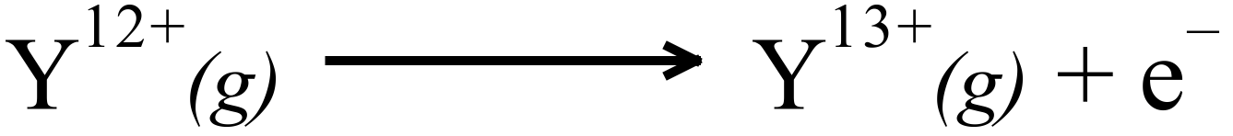 | 54460

The element is most likely to be Y is…
  - Oxygen
  - Sulphur
  - Chlorine
  - Phosphorus

- Which of the following has the greatest core charge?
  - An aluminium atom
  - A chlorine atom
  - A magnesium ion
  - An oxide ion

- Which of the following statement about Group 1 metals is untrue?
  - 1 electron is present in the valence shell of the metal.
  - Their chemical reactivity decreases with atomic number.
  - Their +1 (positive) ions have noble gas configuration.
  - Their core charge is constant.

- In the graphite lattice, what is the number of nearest covalently bonded neighbours for each atom?
  - 2
  - 3
  - 4
  - 6

- The table below gives information about three pure solids designated X, Y and Z.

 | X | Y | Z
Approximate melting point (°C) | 800 | 3500 | 1500
Electrical Conductivity in the solid state | nil | moderate | high
Electrical conductivity in the liquid (melted) state | high | cannot be easily tested | high

Which of the following describes the bonding present in the three substances?

X Y Z
- Covalent molecular Covalent network Ionic
- Ionic Covalent network Metallic
- Ionic Metallic Metallic
- Covalent Molecular Metallic Ionic

- Which of the following will conduct electricity?

    - Molten sulphur
    - Ammonia solution
    - Mercury
    - Sodium hydroxide solution

- IV only
- I and IV only
- I, II and III only
- II, III and IV only

- As atomic number increases across a period, which one of the following generally decreases?
  - Atomic mass
  - Number of valence electrons
  - First ionisation energy
  - Atomic radius

- Which one of the following may have 17 protons, 19 neutrons and 18 electrons?
  - Cl
  - Cl⁻
  - K
  - K⁺
- Complete the following statements:
  - Ionisation energy increases across the periodic table because… (2)

  - Ionisation energy decreases down groups in the periodic table because… (2)

- For each of the following pairs of atoms explain which has the larger atomic radii:

  - A Nitrogen atom or an Oxygen atom (2)

  - A Chlorine atom or a Bromine atom (2)

  - A Magnesium atom or a Magnesium ion (2)

- List four different species that have the electron configuration of 2,8. (2)

- Five elements and their electronic configurations are as follows:
Na: 2,1 Mg: 2,2 He: 2 O:2,6 S:2,8,6
- In a chemical reaction which element is most likely to: (3)
    - Gain 2 e⁻?
    - Lose 2 e⁻?
    - Not react?
- Which element(s) form: (3)
    - Covalent bonds?
    - Metallic bonds?
    - Forms a diatomic element?
- Which element: (2)
          - Is the most reactive?
          - Has the smallest radius?

- A plot showing the successive ionisation energies of Magnesium is given below.

- Define ionisation energy. (1)

- Explain the gentle increase between the first and second ionisation energies for magnesium (1)

- Explain the significant increase in moving from the second to the third ionisation energy for magnesium. (1)

- Explain the gentle increase between the third and tenth ionisation energies for magnesium (1)

- On the chart above indicate where you would expect the eleventh and twelfth ionisation energies for magnesium to be. (1)

- Explain your reason for this location. (1)

- On the same axes above, sketch (and label) the graph you would anticipate for the first eight successive ionisation energies of calcium. (Label as “Ca”) (1)

- On the same axes above, sketch (and label) the graph you would anticipate for the first eight successive ionisation energies of sodium. (Label as “Na”) (1)

- Explain the position of the graphs for magnesium and sodium. (2)

- Species ‘X’ has 2 valence electrons and species ‘Z’ has 7 valence electrons.
With reference to the likely chemical formula of a compound formed between ‘X’ and ‘Y’, discuss the physical properties of this compound. (3)

- For each species listed in the table below, draw the structural formula, representing all valence electron pairs as either : or as – (4)
[For example, water H꞉Ö̤꞉H or H – Ö̤ – H or H – O̲̅ – H and so on]

Species | Structural formula  (showing all valence shell electrons)
Nitrogen trifluoride,
NF₃
Sulfite ion,
SO₃²⁻

- Classify the following as ionic, covalent network, covalent molecular or metallic substances: (3)

O₂, Boron nitride, MgCl₂, Steel, NH₄⁺, SiO₂

IONIC | COVALENT NETWORK | COVALENT MOLECULAR | METALLIC

END OF ASSESSMENT

